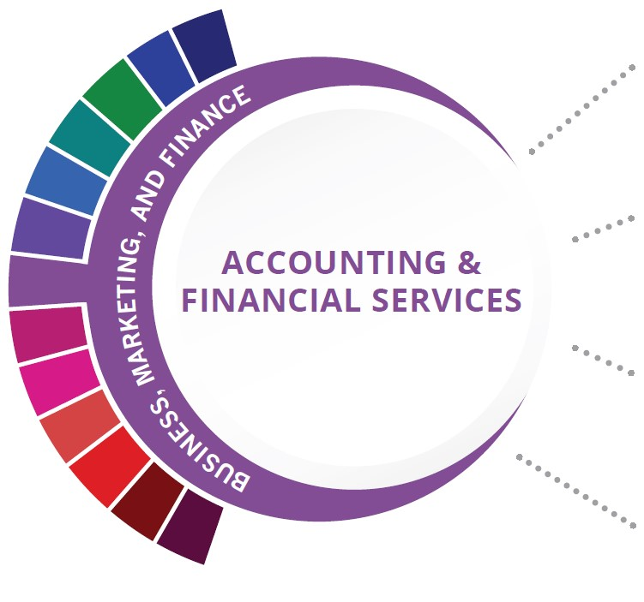
Statewide Program of Study: Accounting & Financial Services; Business, Marketing, and Finance Career Cluster
Level 1 | Principles of Business, Marketing, and Finance  Business Information Management I
Level 2 | Accounting I
Level 3 | Accounting II
Level 4 | None

This Program of Study will also earn the student a Business & Industry Endorsement for high school Graduation.

HIGH SCHOOL/ INDUSTRY CERTIFICATION | CERTIFICATE/ LICENSE* | ASSOCIATE’S DEGREE | BACHELOR’S DEGREE | MASTER’S/ DOCTORAL PROFESSIONAL DEGREE
QuickBooks Certified User | Certified Management Accountant | Real Estate | Accounting | Financial Accounting
OHS: Microsoft Office Specialist or Expert - Excel | Certified Internal Auditor | Financial, General | Financial, General | Business Administration
Certified Insurance Service Representative | Certified Income Specialist | Financial Planning and Services] | Financial Planning and Services] | Financial Planning
 | Certified Public Accountant | Certified Income Specialist | Certified Income Specialist
Additional industry-based certification information is available on the TEA CTE website. For more information on postsecondary options for this program of study, visit TXCTE.org.
Occupations | Median Wage | Annual Openings | % Growth
Accountants and Auditors | $71,469 | 14,436 | 22%
Loan Officers | $68,598 | 2,419 | 19%
Personal Financial Advisors | $86,965 | 1,861 | 52%
Administrative Service Managers | $96,138 | 2,277 | 21%
Insurance Underwriters | $66,206 | 594 | 14%

WORK BASED LEARNING AND EXPANDED
LEARNING OPPORTUNITIES
Exploration Activities: | Work Based Learning  Activities:
Business Professionals of America (BPA)  Future Business Leaders of America (FBLA)  DECA | Internship with local accounting firm  Microsoft Office Specialist (MOS) certifications

The Accounting and Financial Services program of study teaches CTE learners how to examine, analyze, and interpret financial records. Through this program of study, students will learn the skills necessary to perform financial services, prepare financial statements, interpret accounting records, give advice, or audit and evaluate statements prepared by others. This program of study will also introduce students to mathematical modeling tools.
The Business, Marketing, and Finance Career Cluster focuses on careers in planning, organizing, directing, and evaluating business functions essential to efficient and productive business operations.
Successful completion of the Accounting & Financial Services program of study will fulfill requirements of the Business and Industry Endorsement. Revised - July 2020

O'DONNELL HS COURSE INFORMATION

COURSE  NAME | SERVICE ID | PREREQUISITES (PREQ)  COREQUISITES (CREQ) | Grade
Principles of Business, Marketing, and Finance | 13011200 (1 credit)  Course #: 7063 | None | 9-11
Business Information Management I | 13011400 (1 credit)  Course #: 7050 | None | 9-12
Accounting I | 13016600 (1 credit)  Course #: 7054 | None | 10-12
Accounting II | 13016700 (1 credit)  Course #: 7055 | PREQ: Accounting I | 11-12
OHS Industry-Based Certification Opportunities |  | OHS Value-Added Certification Opportunities
POS Industry-Based Certification: Microsoft Office Specialist or Expert-Excel | Offered in BIM II | Microsoft Office Specialist-PowerPoint | Offered in BIM II
Additional Industry-Based Certification not included in POS: Microsoft Office Specialist or Expert-Word | Offered in BIM II | Microsoft Office Specialist-Access | Offered in BIM II

FOR ADDITIONAL INFORMATION ON THE BUSINESS, MARKETING, AND FINANCE CAREER CLUSTER, PLEASE CONTACT:
CTE@tea.texas.gov
https://tea.texas.gov/cte
O'Donnell ISD offers career and technical education programs in Business & Industry, Education & Training, Animal Science, Business Management, and Accounting & Financial Services. Admission to these programs is based on student qualifications. It is the policy of O'Donnell ISD not to discriminate on the basis of race, color, national origin, sex or handicap in its vocational programs, services or activities as required by Title VI of the Civil Rights Act of 1964, as amended; Title IX of the Education Amendments of 1972; and Section 504 of the Rehabilitation Act of 1973, as amended. It is the policy of O'Donnell ISD not to discriminate on the basis of race, color, national origin, sex, handicap, or age in its employment practices as required by Title VI of the Civil Rights Act of 1964, as amended; Title IX of the Education Amendments of 1972; the Age Discrimination Act of 1975, as amended; and Section 504 of the Rehabilitation Act of 1973, as amended. O'Donnell ISD will take steps to assure that lack of English language skills will not be a barrier to admission and participation in all educational and vocational programs. For information about your rights or grievance procedures, contact the high school office.

