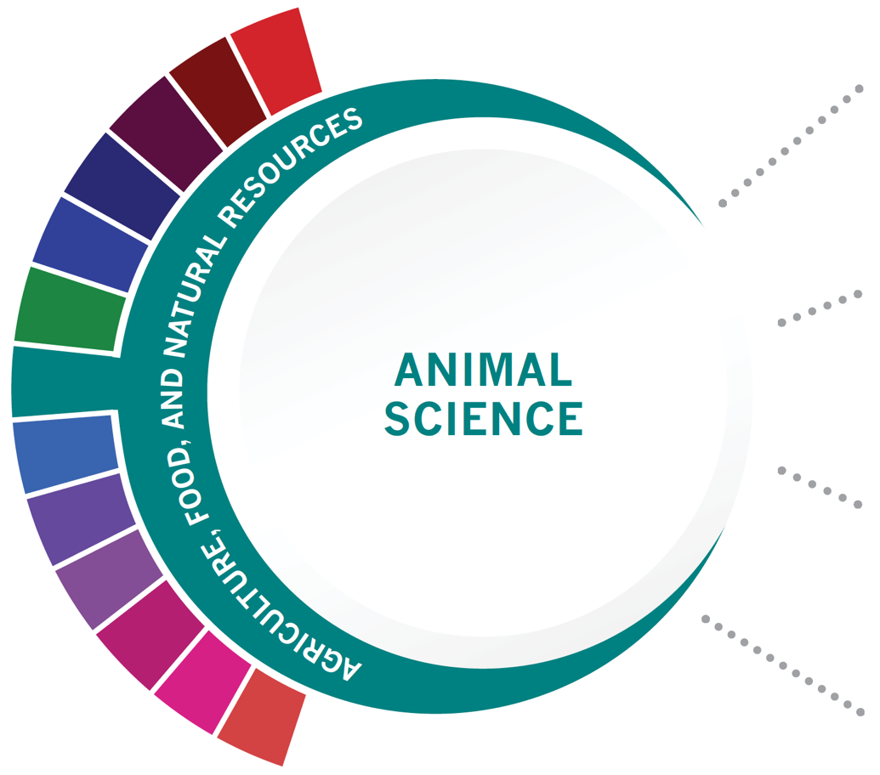
Statewide Program of Study: Animal Science; Agriculture, Food, and Natural Resources Career Cluster
Level 1 | Principles of Agriculture, Food, and Natural Resources
Level 2 | Small Animal Management  Equine Science
Level 3 | Livestock Production
Level 4 | Advanced Animal Science

This Program of Study will also earn the student a Business & Industry Endorsement for high school graduation.

HIGH SCHOOL/ INDUSTRY CERTIFICATION | CERTIFICATE/ LICENSE* | ASSOCIATE’S DEGREE | BACHELOR’S DEGREE | MASTER’S/ DOCTORAL PROFESSIONAL DEGREE
Licensed Veterinary Technician | Pet Groomer | Food Science and Technology | Animal Sciences | Genetics
OHS: Feedyard Technician in Cattle Care and Handling | Veterinary  Technician | Veterinary Studies | Agriculture | Veterinary Medicine
Certified  Veterinary  Assistant | Licensed Breeder | Biotechnology Laboratory Technician | Biology | Biological and Physical Sciences
 |  | Biology Technician | Zoology/ Animal Biology | Biological and Biomedical Sciences
Additional industry-based certification information is available on the TEA CTE website. For more information on postsecondary options for this program of study, visit TXCTE.org.
Occupations | Median Wage | Annual Openings | % Growth
Animal Breeders | $39,135 | 28 | 9%
Animal Scientists | $57,533 | 22 | 12%
Medical Scientists | $63,898 | 435 | 27%
Veterinarians | $93,496 | 294 | 24%
Zoologists and Wildlife Biologists | $67,309 | 45 | 32%

WORK BASED LEARNING AND EXPANDED
LEARNING OPPORTUNITIES
Exploration Activities: | Work Based Learning  Activities:
Texas FFA | Agri-Science Fair  4H  Volunteer at a local farm or veterinary office  FFA Supervised Agriculture Experience (SAE)

The Animal Science program of study focuses on the science, research, and business of animals and other living organisms. It teaches CTE learners how to apply biology and life science to real-world life processes of animals and wildlife, either in laboratories or in the field, which could include a veterinary office, a farm or ranch, or any outdoor area harboring animal life. Students may also research and analyze the growth and destruction of species and research or diagnose diseases and injuries of animals.
The Agriculture, Food, and Natural Resources (AFNR) Career Cluster focuses on the essential elements of life—food, water, land, and air. This career cluster includes a diverse spectrum of occupations, ranging from farmer, rancher, and veterinarian to geologist, land conservationist, and florist. It also includes non-traditional agricultural occupations like wind energy, solar energy, and oil and gas production.

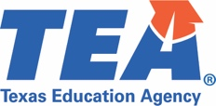
Successful completion of the Animal Science program of study will fulfill requirements of a Business and Industry endorsement or STEM endorsement if the math and science requirements are met. Revised - July 2020

O'DONNELL HS COURSE INFORMATION

COURSE  NAME | SERVICE ID | PREREQUISITES (PREQ)  COREQUISITES (CREQ) | Grade
Principles of Agriculture, Food, and Natural Resources | 13000200 (1 credit)  Course #: 7000 | Offered Every Year | 9-12
Small Animal Management | 13000400 (0.5 credit)  Course #: 7006 | Offered Even Years | 10-12
Equine Science | 13000500 (0.5 credit)  Course #: 7016 | Offered Even Years | 10-12
Livestock Production | 13000300 (1 credit)  Course #: 7001 | Offered Odd Years | 10-12
Advanced Animal Science | 13000700 (1 credit)  Course #: 7015 | PREQ: Biology and Chemistry or Integrated Physics and Chemistry (IPC); Algebra I and Geometry; and either Small Animal Management, Equine Science, or Livestock Production; offered every year | 11-12
OHS Industry-Based Certification Opportunities |  | OHS Value-Added Certification Opportunities
POS Industry-Based Certification: Feedyard Technician in Cattle Care and Handling | Offered Spring Semester in Advanced Animal Science | Hunter Safety | TBD when offered
Additional Industry-Based Certification not included in POS: Feedyard Technician in Machinery Operation, Repair & Maintenance | Offered Fall Semester in Advanced Animal Science
Additional Industry-Based Certification not included in POS: OSHA 30 Hour General Industry | TBD when offered

FOR ADDITIONAL INFORMATION ON THE AGRICULTURE, FOOD, AND NATURAL RESOURCE CAREER CLUSTER,
PLEASE CONTACT: Les Hudson | Les.Hudson@tea.texas.gov
https://tea.texas.gov/cte

O'Donnell ISD offers career and technical education programs in Business & Industry, Education & Training, Animal Science, Business Management, and Accounting & Financial Services. Admission to these programs is based on student qualifications. It is the policy of O'Donnell ISD not to discriminate on the basis of race, color, national origin, sex or handicap in its vocational programs, services or activities as required by Title VI of the Civil Rights Act of 1964, as amended; Title IX of the Education Amendments of 1972; and Section 504 of the Rehabilitation Act of 1973, as amended. It is the policy of O'Donnell ISD not to discriminate on the basis of race, color, national origin, sex, handicap, or age in its employment practices as required by Title VI of the Civil Rights Act of 1964, as amended; Title IX of the Education Amendments of 1972; the Age Discrimination Act of 1975, as amended; and Section 504 of the Rehabilitation Act of 1973, as amended. O'Donnell ISD will take steps to assure that lack of English language skills will not be a barrier to admission and participation in all educational and vocational programs. For information about your rights or grievance procedures, contact the high school office.

